do YOU WANT TO HAVE ALL THE OPPORTUNITIES
and BENEFITS THAT CITIZENSHIP PROVIDES?
LET US HELP YOU!

FREE CITIZENSHIP WORKSHOP

DATE | TIME
INSERT LOCATION NAME
Insert Address

Applying is simple with help from our expert volunteers
who speak Spanish, Arabic, Cantonese and more!
You may even qualify for financial help.
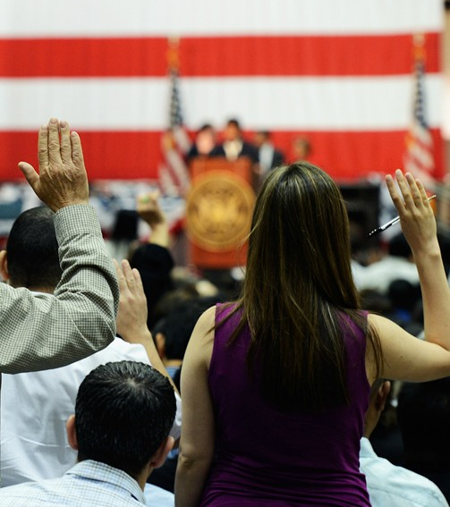
TO QUALIFY FOR CITIZENSHIP YOU MUST:
- Be at least 18 years old.
- Be a lawful permanent resident and lived continuously in the U.S. for 5 years or 3 years if you are married to a U.S. citizen.
- Speak, read and write Basic English or be over the age of 55.
- Not be convicted of any felonies.

TO APPLY AT OUR WORKSHOP BRING:
- Green card, social security card and driver’s license/state I.D.
- Address and job/school history for the last 5 years.
- List of ALL trips taken outside of the U.S. for the last 5 years
- Information for ALL children and current/former spouses.
- Check or money order for $725 payable to the Department of Homeland Security, or qualify for a fee waiver.

TO QUALIFY FOR A FEE WAIVER BRING:
- 2016 Income Tax or Proof of Public Benefits

Citizenship gives you a voice and a vote, freedom to travel wherever, whenever and the power to bring your family together and keep them together in the U.S.

INSERT LOGOS OF LOCAL ORGANIZATIONS
For Information: www.newamericanscampaign.org |To Register: INSERT NUMBER

